להב-חרב ולהבת-אש

אבנר רמו
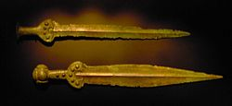

In the Book of Judges we find:
ויקח את החרב מעל ירך ימינו; ויתקעה בבטנו.
ויבא גם הנצב [] אחר הלהב, ויסגר החלב בעד הלהב, כי לא שלף החרב מבטנו;
“And he took the sword of his right thigh and jabbed it into his belly.
And the [] hilt also went [in] after the blade, and the fat closed upon the blade, for he did not draw the sword out of his belly” (Jud 3:21-22).

The English (but not the Greek) translator believed that here of the word: להב means: "blade.” In addition, the logic of these verses suggests that the words of verse Jud 3:22 are a letter substitution, a letter and a word deletion, and a word disorder of:
ויבא אחרי הלהב גם נצב-החרב פנימה, ויסגר העור עליהם, ולכן לא נשלפה החרב מבטנו - “And after the blade came in the sword’s hilt, and the skin closed upon them, and therefore, the sword was not withdrawn from his belly.”

Yet in the Book of Job the words: להב חנית was translated to English as: “glittering spear” (Job 39:23), and in verse 17:7 of the Book of Samuel the words: להבת חניתו were translated to: “his spear’s head.”

In the Book of Nahum we read about: להב חרב - “flashing sword” (Nah 3:3). The Greek translator wrote here: “glittering sword.” However, the comparison between these verses suggests that the words: להב חנית mean: “spear’s blade”, the words: להבת חניתו are a letter insertion error of: להב-חניתו, and the words: להב-חרב mean: “sword’s blade.”

In the Book of Genesis we find: וישכן מקדם לגן-עדן את-הכרבים ואת להט החרב המתהפכת - “And he placed in front of the garden of Eden the Cherubim and the turning flaming sword” (Gen 3:24).

The understanding of the translator indicates that he believed that here the first word: וישכן is a letter substitution error of: וישם. The comparison between these verses suggests that here the words: להט החרב המתהפכת are a letter insertion, and substitution error of:
להב החרב המתהפך - “the turning sword’s blade.”

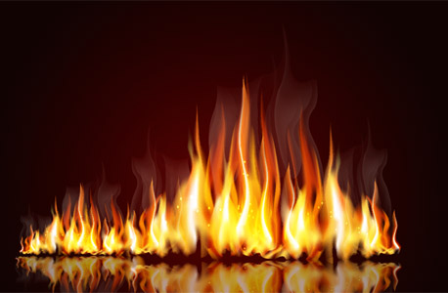

In 14 out of total of 15 biblical verses that contain the word: להבה we also find the word: אש - "fire.”

In the Book of Isaiah we read: נגה אש להבה - “glare of flaming fire” (Is 4:5; see also: Hos 7:6; The 2:3).

The understanding of the translators indicates that they believed that the words: אש להבה are a letter substitution and a word disorder of: להבת-אש - “flaming fire”, but such a term does not appear in the Bible.

On the other hand, we read in the Book of Isaiah: להב אש אוכלה - “flame of devouring fire” (Is 29:5; see also: Is 30:30; Joel 2:5).

The understanding of the translators indicates that they believed that here the words:
להב אש אוכלה are a letter substitution, and a letter deletion error of: להבת-אש אוכלת - “a devouring flame of fire.”

In the Book of Psalms we read: קול יהוה חצב; להבות אש - “YHWH’s voice hews out fire’s flames” (Ps 29:7).

The Greek translator wrote here: “divides”, but the reading of verses Lev 13:38; Eze 21:3; and Pro 16:27 suggests that here the word: חצב is a letter substitution, and order type error of: צרב - "is scorching” or of: שרף - "is burning.”

Yet in the Book of Isaiah we find about God: גערתו בלהבי-אש - “His rebuke with flames of fire” (Is 66:15).

However, the logic of this verse, and the comparison between these verses suggest that these words are a letter substitution error of: גערתו כלהבות-אש - “His rebuke is like flames of fire.”

In the Book of Psalms we read: עשה מלאכיו רוחות; []משרתיו אש להט - “He made winds his messengers, [] flaming fire His servants” (Ps 104:4).

The understanding of the translators, and the Hebrew syntax and grammar suggest that these words are a letter deletion, a letter substitution, and word disorder of:
עשה רוחות למלאכיו; ולהבות-אש למשרתיו - “He made winds to his messengers and flames of fire to His servants.”

In the Book of Job we find: [] נפשו גחלים תלהט; ולהב[] מפיו יצא - “His breath kindles coals; and flame comes out of his mouth” (Job 41:13).

However, the understanding of the English translator, the Hebrew grammar, and the comparison between these verses suggest that these words are a letter substitution, and a letter and a word deletion error of: ורוח-נפשו גחלים תלהב; ולהבת-אש מפיו תצא - “And his breath will flame coals, and a flaming-fire shall come out of his mouth.”

Similarly, we find in the Book of Psalms: [] אש לפניו תלך; ותלהט סביב צריו - “[] fire shall go before him; and it shall burn His adversaries round-about” (Ps 97:3; see also: Ps 83:15; 106:18).

However, the comparison between these verses suggests that these words are a letter substitution, and a word deletion error of: ולהבת-אש לפניו תלך; ותלהב סביב צריו - “Ans a flaming-fire shall go before him; and it shall flame His adversaries round-about.”

